**Decision tree:**

Decision Trees are a type of Supervised Machine Learning, where the data is continuously split according to a certain parameter. The tree can be explained by two entities, namely decision nodes and leaves. The leaves are the decisions or the final outcomes. And the decision nodes are where the data is split.

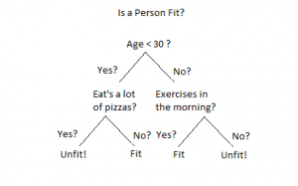

An example of a decision tree can be explained using above binary tree. Let’s say you want to predict whether a person is fit given their information like age, eating habit, and physical activity, etc. The decision nodes here are questions like ‘What’s the age?’, ‘Does he exercise?’, ‘Does he eat a lot of pizzas’? And the leaves, which are outcomes like either ‘fit’, or ‘unfit’. In this case this was a binary classification problem (a yes no type problem).

**2. Linear regression Algorithm:**

Linear Regression is a machine learning algorithm based on supervised learning. It performs a regression task. Regression models a target prediction value based on independent variables. It is mostly used for finding out the relationship between variables and forecasting. Different regression models differ based on – the kind of relationship between dependent and independent variables, they are considering, and the number of independent variables being used.

Linear regression performs the task to predict a dependent variable value (y) based on a given independent variable (x). So, this regression technique finds out a linear relationship between x (input) and y(output). Hence, the name is Linear Regression.

In the figure above, X (input) is the work experience and Y (output) is the salary of a person. The regression line is the best fit line for our model.

**Linear Equation y = mx + b, m is coefficient, x is an independent variable, and b is the intercept.**